JOURNAL SUBSCRIPTIONS 2017
SL.NO | TITLE | PERIODICITY
1 | AMERICAN JOURNAL OF ORTHODONTICS AND DENTOFACIAL ORTHOPEDICS | AJODO | MONTHLY
2 | COMMUNITY DENTISTRY AND ORAL EPIDEMIOLOGY | BI-MONTHLY
3 | DENTAL ABSTRACTS | Elsevier | BI-MONTHLY
4 | DENTAL MATERIALS | DM | MONTHLY
5 | DENTOMAXILLOFACIAL RADIOLOGY | DMFR | MONTHLY
6 | JOURNAL OF CLINICAL PERIODONTOLOGY | JCP | MONTHLY
7 | JOURNAL OF ENDODONTICS | JOE | MONTHLY
8 | JOURNAL OF ORAL AND MAXILLOFACIAL SURGERY | JOMS | MONTHLY
9 | JOURNAL OF ORAL PATHOLOGY AND MEDICINE | JOPM | MONTHLY
10 | JOURNAL OF OROFACIAL PAIN | JORFPN | QUARTERLY
11 | JOURNAL OF ORTHODONTICS | J.ORTHO | QUARTERLY
12 | JOURNAL OF PERIODONTOLOGY | JP | MONTHLY
13 | JOURNAL OF PROSTHETIC DENTISTRY | JPD | MONTHLY
14 | JOURNAL OF PUBLIC HEALTH DENTISTRY | JPHD | QUARTERLY
15 | ORAL SURGERY,MEDICINE,PATHOLOGY,RADIOLOGY | OOO | MONTHLY
16 | ORAL AND MAXILLOFACIAL SURGERY CLINICS OF NORTH AMERICA | OMFSCNA | QUARTERLY
17 | DENTAL TRAUMATOLOGY | DT | BI-MONTHLY
19 | INTERNATIONAL JOURNAL OF ORAL AND MAXILLOFACIAL SURGERY | IJOMS | MONTHLY
20 | INTERNATIONAL JOURNAL OF PERIODONTICS AND RESTORATIVE DENTISTRY | IJPRD | BI-MONTHLY
21 | INTERNATIONAL JOURNAL OF PROSTHODONTICS | IJP | BI-MONTHLY
22 | JOURNAL OF CRANIO MAXILLOFACIAL SURGERY | JCMFS | MONTHLY
23 | INTERNATIONAL JOURNAL OF PED. DENTISTRY | IJPD | BI-MONTHLY
24 | JOURNAL OF DENTAL RESEARCH | JDR | MONTHLY
25 | JOURNAL OF PERIODONTAL RESEARCH | JPR | BI-MONTHLY
26 | PEDIATRIC DENTISTRY | PD | BI-MONTHLY
27 | SEMINARS IN ORTHODONTICS | SO | QUARTERLY
28 | QUINTESSENCE INTERNATIONAL | QI | MONTHLY
29 | JOURNAL OF CLINICAL ORTHODONTICS | JCO | MONTHLY
30 | OPERATIVE DENTISTRY | OD | BI-MONTHLY
31 | SOC.FOR THE ADVN OF ANAESTHESIA IN DENTISTRY-SAAD | SAAD | YEARLY
32 | ORAL HEALTH AND PREVENTIVE DENTISTRY | OHPD | QUARTERLY
33 | IMPLANT DENTISTRY | IMP.D | BI-MONTHLY
34 | JOURNAL OF DENTISTRY | JD | MONTHLY
35 | PERIODONTOLOGY 2000 | QUARTERLY
36 | CANCER | CAN. | FORTNIGHTLY
37 | CANCER CYTOPATHOLOGY | CAN.CYTO | BI-MONTHLY
38 | INTERNATIONAL JOURNAL OF ORAL AND MAXILLOFACIAL IMPLANTS | JOMI | BI-MONTHLY
39 | ORAL IMPLANTOLOGY | QUARTERLY
40 | CLEFT PALATE CRANIOFACIAL JOURNAL | CPCJ | BI-MONTHLY
41 | DENTAL UPDATE | DU | MONTHLY
42 | EUROPEAN JOURNAL OF ORTHODONTICS | EJO | BI-MONTHLY
43 | GERODONTOLOGY | GER | QUARTERLY
44 | JOURNAL OF PROSTHODONTICS | J.PRO | MONTHLY
45 | ORAL DISEASES | OD | MONTHLY
46 | COMMUNITY DENTAL HEALTH | CDH | QUARTERLY
47 | BRITISH JOURNAL OF ORAL AND MAXILLOFACIAL SURGERY | BJOMS | MONTHLY
48 | DENTAL CLINICS OF NORTH AMERICA | DCNA | QUARTERLY
49 | JOURNAL OF ESTHETIC AND RESTORATIVE DENTISTRY | JERD | BI-MONTHLY
50 | SURGICAL CLINICS OF NORTH AMERICA | SCNA | BI-MONTHLY
51 | JOURNAL OF FORENSIC SCIENCES | JFS | BI-MONTHLY
52 | INTERNATIONAL ENDODONTIC JOURNAL | IEJ | MONTHLY
53 | ORAL ONCOLOGY | ORAL ONCO | MONTHLY
54 | PLASTIC AND RECONSTRUCTIVE SURGERY | PRS | MONTHLY
55 | JOURNAL OF AMERICAN DENTAL ASSOCIATION | JADA | MONTHLY
56 | JOURNAL OF CLINICAL PEDIATRIC DENTISTRY | JCPD | QUARTERLY
57 | COMPENDIUM OF CONTINUING DENTAL EDUCATION | COMPENDIUM | MONTHLY
58 | ORAL IMPLONTOLOGY | QUARTERLY
59 | LANCET | QUARTERLY
60 | NEW ENGLAND JOURNAL OF MEDICINE | WEEKLY

61 | DENTAL PUBLIC HEALTH | QUARTERLY
62 | DENTAL MATERIALS
63 | INDIAN JOURNAL OF DENTAL RESEARCH-2017
64 | JOURNAL OF CLEFT LIP PALATE AND CRANIOFACIAL ANOMALIES
65 | JOURNAL OF FORENSIC DENTAL SCIENCES
66 | JOURNAL OF INDIAN ACADEMY OF ORAL MEDICINE AND RADIOLOGY
67 | JOURNAL OF INDIAN ASSOCIATION OF PUBLIC HEALTH DENTISTRY
68 | JOURNAL OF INDIAN SOCIETY OF PERIODONTOLOGY
69 | JOURNAL OF INDIAN SOC. OF PEDODONTICS AND PREVENTIVE DENTISTRY
70 | SAAD

Subject wise No. of Books
Sl.  No | Subjects | No. of  Books
1 | Oral Surgery | 700
2 | Dictionaries & Encyclopedia | 180
3 | Dental Anatomy | 258
4 | General Surgery | 305
5 | Biochemistry | 475
6 | Miscellaneous | 349
7 | Periodontics | 267
8 | Oral Medicine & Radiology | 351
9 | Dental Materials | 292
10 | Orthodontics | 415
11 | Anatomy | 578
12 | General Medicine | 436
13 | Community Dentistry | 284
14 | Pedodontics | 243
15 | Prosthodontics | 425
16 | Oral Pathology | 388
17 | General Pathology & Microbiology | 442
18 | Pharmacology | 437
19 | Physiology | 397
20 | Behavioural Science | 90
21 | MCQ’s | 315
22 | General Dentistry | 210
23 | Craniofacial Growth Series | 35
24 | Conservative Dentistry | 383
 | Total | 8255

Subjectwise no of titles
Sl.  No | Subject | No. OF  Titles
1 | Oral Surgery | 245
2 | Dictionaries & Encyclopedia | 150
3 | Dental Anatomy | 74
4 | General Surgery | 75
5 | Physiology and Biochemistry | 250
6 | Miscellaneous | 220
7 | Periodontics | 96
8 | Oral Medicine & Radiology | 180
9 | Dental Materials | 70
10 | Orthodontics | 170
11 | Anatomy | 270
12 | General Medicine | 225
13 | Community Dentistry | 120
14 | Pedodontics | 90
15 | Prosthodontics | 240
16 | Oral Pathology | 170
17 | General Patho & Microbiology | 176
18 | Pharmacology | 141
19 | Biochemistry | 81
20 | Behavioural Science | 40
21 | M.C.Q’s | 97
22 | General Dentistry | 140
23 | Craniofacial Growth Series | 35
24 | Conservative Dentistry | 155
 | Total | 4100

Department Library
Pharmacology : 10

Implant logy : 10

Oral Pathology : 93

Conservative : 21

Oral Surgery : 05

Periodontics : 25

Community : 12

Prosthodontics : 43

Orthodontics : 85

Principal Office : 09

Oral Medicine : 22

Pedodontics : 63

Electrical Maintenance : 04

General Medicine : 06

Library as a Learning Resource Centre
Learning Resource Committee
The library (LRC) has an ‘Advisory Committee’, called the Learning Resource Committee, which is part of the IQAC. It is composed of the following faculty members:

- Prof. Swathi Setty,, Convener
- Prof. Venkatesh Anehosur, Member
- Prof. Anand Tavargeri, Member
- ASST Prof. Dr.Kirankumar , Member
- Mr. BS Halemani, Librarian & Member

The Committee is charged with procurement of books and journals, operations of the internet browsing centre in the LRC, and preparation of teaching aids. It meets twice a year, usually in the first and second half of the calendar year, and as and when necessary. Realising that the internet usage in the college was fast increasing—based on statistics available to the LRC (nearly 150 members were logged in/hour at any given point in time)—it was deemed that the existing 2 Mbps leased line was insufficient for the level of usage. Hence, in December 2009, the Committee decided to suggest to the Principal to submit a proposal to the college’s Management to enhance the connectivity from 2 Mbps to 4 Mbps. The increase in bandwidth took effect in February 2012.

INFRASTRUCTURE

Learning Resource Centre
Learning Resource Centre is situated on the top floor of the institution, occupying a total 1060 sq meter (11400 sq.ft) area with 350 seating capacity.
Total seating capacity
The LRC seats 350.

Sections
Undergaraduate
Graduate
Faculty
Group Think Cabins
Digital Library
Server Room
Reprography
LEARNING RESOURCE CENTRE HOURS

Open for all 365 days
07.00 HRS to 23.30 HRS on Week Days
08.00 HRS to 23.00 HRS on Holidays
07.00 HRS to 01.00 HRS during Exams

Layout of the library (individual reading carrels, lounge area for browsing and relaxed reading, IT zone for accessing e-resources)
The LRC includes a stack area, under- and postgraduate student reading areas, faculty lounge, Internet browsing centre, audio-visual room, circulation counter, photocopy/printing section, and Group Think for discussions.

A clear and prominent floor plan is displayed in the LRC; there are adequate sign boards indicating exits and fire safety; access to the LRC for differently-abled is through the use of need-based ramps.

List of LRC staff with their qualifications
The following is the list of LRC staff and their qualifications:

- Mr. BS Halemani, MLISc (Senior Librarian)
- Mrs. Poornima G. Rao, MLISc (Assistant Librarian)
- Mr. Prashant H, BLISc (Library Assistant)
- Mr. Gangadhar Gali (Computer Operator)

Library holdings:

- Print (books, back volumes, theses, journals)
- Books = 8255
- Back volumes = 2974
- Theses = 1203
- Journals = 70

Average number of books added during the last three years

The average number of books added since accreditation in 2009 is 116 (580 in five years).

Electronic (e-books, e-journals)

e-book
296
e-journals:
- HELINET Dentistry = 41
- HELINET Life Sciences = 266
- EBSCO Oral Sciences = 201
- Special collections (e.g., text books, reference books)
As above.

Book bank
Book Bank facility is available

Book bank for ST Students

Book Bank for General Students./Yearly issue

Question bank
Both print and e-format question banks are available for I–IV BDS as well as for MDS of all specialties.

ICT deployed in the library

Library automation
The LRC services are automated through a software programme called the Educational Enterprise Resource Planning and Management System (or EERPMS), developed by college’s Management. All LRC material is bar-coded and is circulated through the aforementioned software. The EERPMS has the Online Publication Access Catalogue (OPAC) module for easy access to the LRC material. In the preceding five years, an updated version of the EERPMS has been installed.
Total number of computers for general access
The LRC houses 14 computers for general access—12 for browsing the Internet and two for accessing the LRC material.

Total numbers of printers for general access
Printers are available for general access in the photocopy/printing section of the LRC.

Internet band width speed
The Internet band width speed in the college building and LRC is 4 Mbps.

Institutional Repository
In 2014, the college library commenced the compilation of a college Digital Repository, assembling together e-copies of PDFs of journal articles/theses, class lecture notes, PowerPoint presentations, etc., for access by all members of the college. The Digital Repository is accessible on the college intranet using the college IP address and allows computer-based access and search to extensive amounts of college teaching-learning and scholarly material such as published papers, dissertations and e-books (Fig. 4.3).

Content management system for e-learning
Several materials prepared and developed by the college for modules such as BLS, Infection Control, Laboratory Safety, as well as other policies, are accessible to students using an username and password on the college’s website (http://www.sdmcds.org/manuals.html).

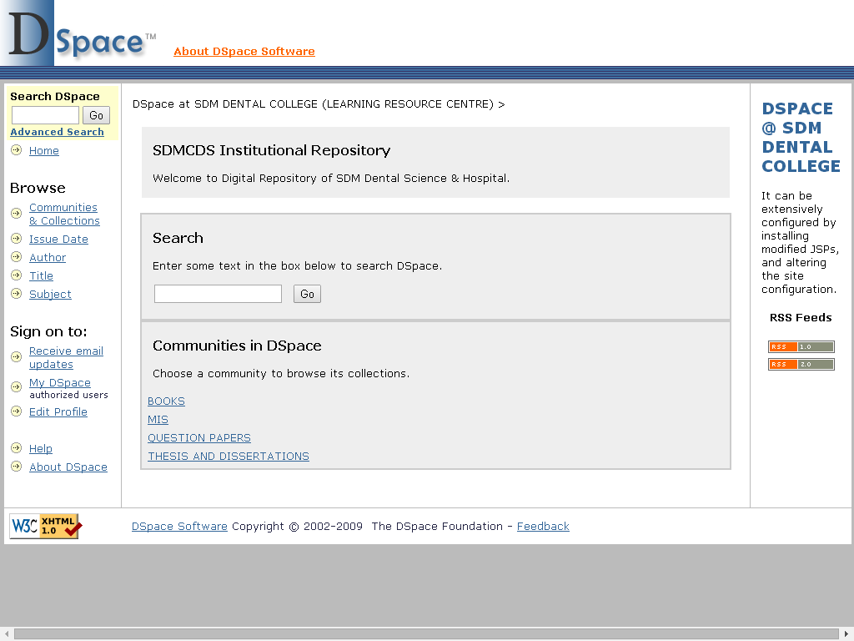
Fig. 4.3: A screenshot of the search page of the college’s digital repository.

Participation in resource sharing networks/consortia (like INFLIBNET)
The college participates in resource sharing networks/consortia such as HELINET (through it affiliating university) as well as DELNET.

Details of specialised services provided by the library

Reference
Yes. Facility exists for selective dissemination of information, with the LRC providing both general and specific references.

Reprography/scanning
Yes. The LRC includes a reprography/printing/scanning facility.

Inter-library Loan Service
Yes. The LRC has inter-library borrowing facility with a number of libraries covering different types of tertiary institutions—basic sciences, health sciences and dental sciences, within the Hubli-Dharwad region as well as other regions of the state. Students also directly avail the library facilities in the SDM College of Medical Sciences.

Information Deployment and Notification
Students and faculty members are made aware of the new arrivals by exhibiting the same on the display section, which is located prominently within the LRC. Notices on new acquisitions are also displayed on the LRC announcement board. Furthermore, faculty members are informed of new arrivals through circulation of notices/emails to different departments.

OPAC
As aforementioned, the EERPMS has the OPAC module for easy access to LRC material, an updated version of which has been installed in the preceding five years. The OPAC module has an option to view new arrivals in the LRC.

Internet Access
The college and the LRC provide WiFi Internet access of 4 Mbps band width.

Downloads
Students and faculty members’ queries related to downloading content are handled by the LRC’s concerned technical staff, and resolution provided on a need basis.

Printouts
The printouts generated in the photocopy section—outsourced to a private vendor—is listed in Table

Year-wise breakup of the prints generated in the library’s printing section

Year | Approximate Average Number of Copies/Day
2009-10 | 1200−1500
2010-11 | 1200−1500
2011-12 | 1200−1500
2012-13 | 800−1000
2013-14 | 800−1000
2014-15 | 800−1000
2015-16 | 800−1000

Reading list/Bibliography compilation
The OPAC module provides access to the LRC’s reading list and bibliography compilation.

In-house/remote access to e-resources
While the EBSCO database and Quintessence group publications provide ‘in-house’ access to e-learning resources, the HELINET consortia provide remote access to e-resources.

User Orientation
Newly admitted I BDS and I MDS students, as well as newly appointed faculty members, are orientated to the use of the LRC services and resources, for example, the use and application of the OPAC. The orientation includes providing information on how to gain access to print resources in-house and online e-resources. Other information services such as Current Awareness Services (CAS) and Selective Dissemination of Information (SDI) are also provided by the LRC to its users.

Assistance in searching Databases
As aforementioned, the LRC staff educates and guides students and faculty members in the use of the OPAC and other e-resources.

INFLIBNET/HELINET

As aforementioned, the college participates in resource sharing networks/consortia such as HELINET (through it affiliating university, the RGUHS) as well as DELNET.

The budget sanctioned and actual expenditure of the LRC

Year | Budget Sanctioned (in ₹) | Actual Expenditure (in ₹)
2009-10 | 30,000,00 | 30,16,274
2010-11 | 30,000,00 | 29,72,190
2011-12 | 30,000,00 | 34,70,564
2012-13 | 30,000,00 | 30,71,619
2013-14 | 30,000,00 | 31,19,986
2014-15 | 30,000,00
2015-16 | 30,000,00
2016-17 | 30,000,00

Strategies used by the library to collect feedback from its users

The college obtains feedback from the students on the services offered in the LRC. The survey includes responses on the availability of books at the LRC, the ambience, personnel, and work hours of the LRC. A majority of students have rated these parameters as ‘Very Good’ or ‘Good’. The Principal discusses the results of the survey with the Convener of the Learning Resource Committee and the Librarian for appropriate analyses, and implementing possible improvements thereof. Consequently, improvement in manpower and the attitude of LRC support staff has been discussed and a decision taken to retain efficient and well-behaved staff.

List the efforts made towards the infrastructural development of the library in the last four years.

Several infrastructure upgrades have been made since last NAAC accreditation—in 2011, the Group Think section was added which allows discussions and exchange of ideas in the LRC; the internet bandwidth was increased from 2 Mbps to 4 Mbps; 19 new computers and one server was installed in October 2011 while six wooden book racks were added in March 2011.

